# **Descriptive Statistics in JASP:**

Click “File” 🡪 “Open” 🡪 “Data Library” to get started with a practice dataset included in JASP. If you have an excel file or .csv you can use the Computer option to select that file.

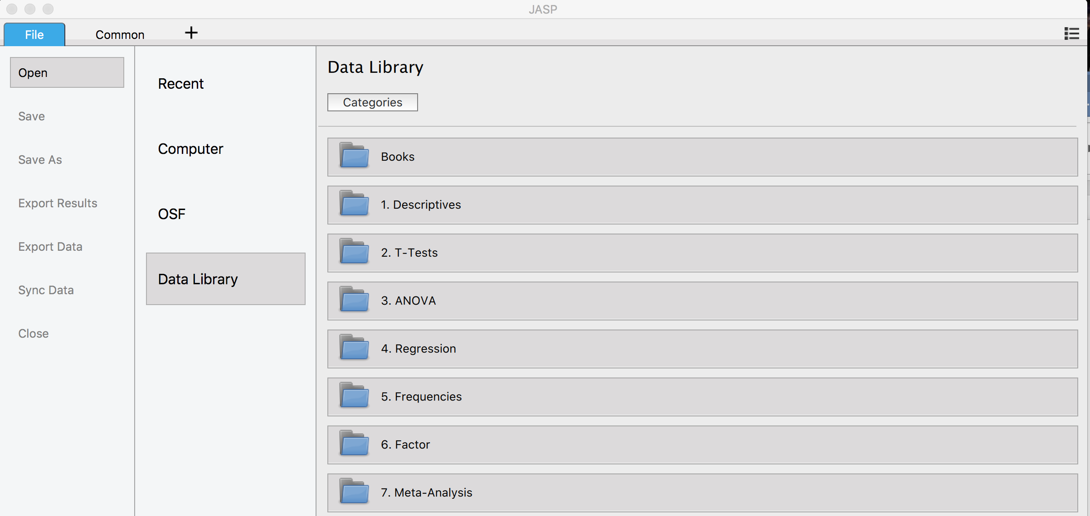

The specific file we want is “Fear of Statistics”, which is located in the “1. Descriptives” Folder.

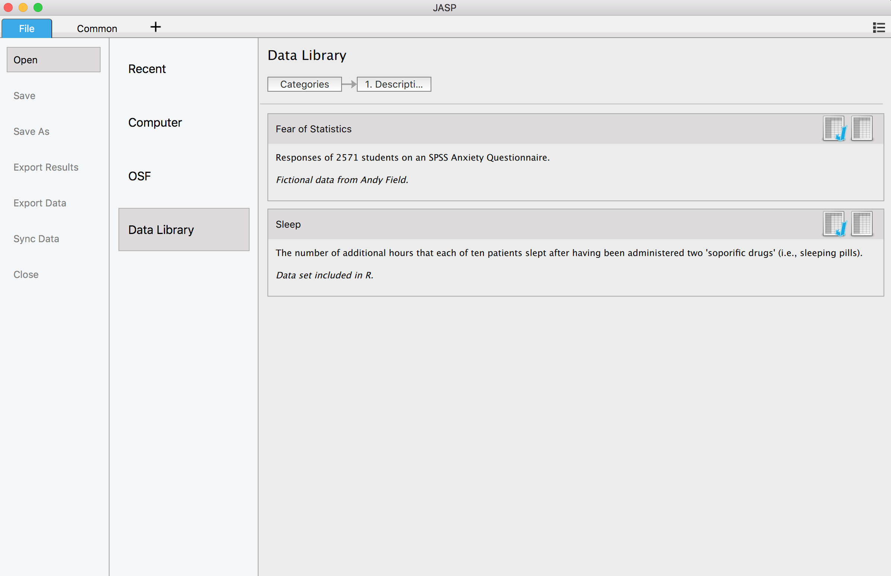

Double click on the J icon  to open the dataset in JASP. Note that JASP opens a new window for every new dataset you open.

Here’s the dataset we selected:

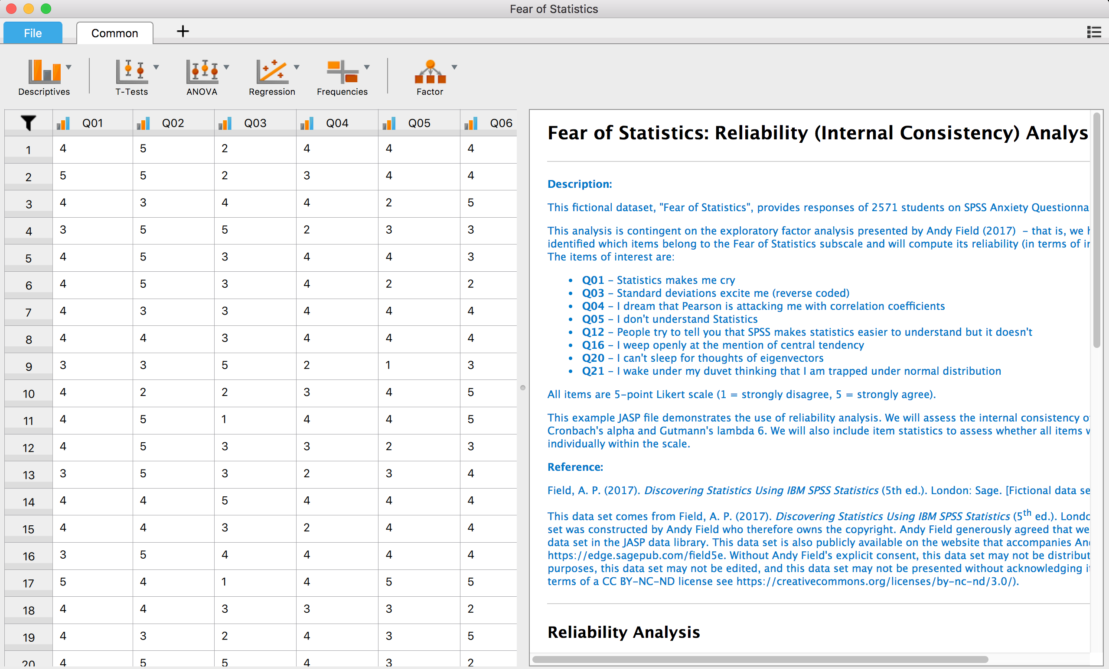

To get descriptive statistics for each variable (column), we can click on “Descriptives” 🡪 “Descriptive Statistics”.

PICTURE

Here you will do basically what you did for the histograms document, but focus on statistics options instead … we want them to select mean, median, mode, variance, range, SE mean, skew, kurtosis.